Understandings, Applications and Skills (This is what you maybe assessed on)

 | Statement | Guidance
1.5.U1 | Cells can only be formed by division of pre-existing cells. | Students should be aware that the 64 codons in the genetic code have the same meanings in nearly all organisms, but that there are some minor variations that are likely to have accrued since the common origin of life on Earth.
1.5.U2 | The first cells must have arisen from non-living material.
1.5.U3 | The origin of eukaryotic cells can be explained by the endosymbiotic theory. | Evidence for the endosymbiotic theory is expected. The origin of eukaryote cilia and flagella does not need to be included.
1.5.A1 | Evidence from Pasteur’s experiments that spontaneous generation of cells and organisms does not now occur on Earth.

Recommended resources:
http://bioknowledgy.info/15-the-origin-of-cells.html
Allott, Andrew. Biology: Course Companion. S.l.: Oxford UP, 2014. Print.

1.5.A1 Evidence from Pasteur’s experiments that spontaneous generation of cells and organisms does not now occur on Earth. AND Nature of Science: Testing the general principles that underlie the natural world - the principle that cells only come from pre-existing cells needs to be verified. (1.9)

Louis Pasteur designed an experiment to test whether sterile nutrient broth could spontaneously generate microbial life. To do this, he set up two experiments.  - In both, Pasteur added nutrient broth to flasks and bent the necks of the flasks into S shapes  - Each flask was then heated to boil the broth in order than all existing microbes were killed.  - After the broth had been sterilized, Pasteur broke off the swan necks from the flasks in Experiment 1, exposing the nutrient broth within them to air from above.  - The flasks in Experiment 2 were left alone. | 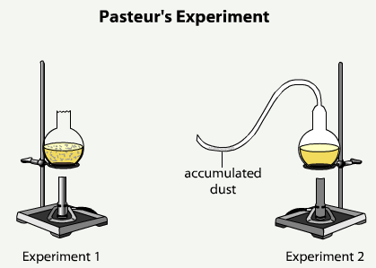
 | http://bcs.whfreeman.com/thelifewire/content/chp03/0302003.html

- In which flask(s) would you expect microbes grow?

- Explain the reasons for your answer to the above question.

- How does the evidence derived from this experiment refute the idea of spontaneous generation?

- Give reasons why this experiment was a necessary one.

1.5.U1 Cells can only be formed by division of pre-existing cells.

- State the three core ideas of cell theory:
1.

2.

3.

- Aside from Pasteur’s experiments what evidence do Biologists have that cells can only be formed by division of pre-existing cells? Outline the evidence below:

- Cells are highly complex structures …

- All known examples of growth …

- Viruses are produced from simpler subunits …

- Genetic code is universal …

1.5.U2 The first cells must have arisen from non-living material.

If we accept that there were times in the history of the Earth when cells did not exist then it is an obvious point that ‘The first cells must have arisen from non-living material’. The only other possible explanation is that life, in the form of cells, was transported here from elsewhere in the universe. As illustrated above, it is extremely difficult (and given our level of technology currently impossible), to generate cells from anything but other cells. So how did the first cells arise?

- We have evidence and ideas how some of the key problems might have been solved. Outline the following points:

  - The non-living synthesis of simple organic molecules, e.g. sugars and amino acids

  - The assembly of these organic molecules into polymers

  - The formation of polymers that can self-replicate (enabling inheritance)

  - Formation of membranes to package the organic molecules

1.5.U3 The origin of eukaryotic cells can be explained by the endosymbiotic theory.

- State the definition of endosymbiotic theory:

- As shown by the diagram below there are several key stages in the theory.

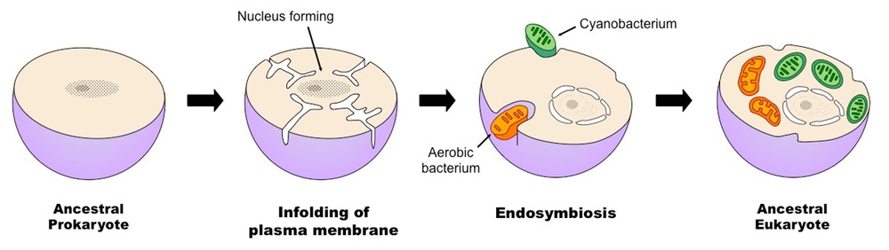
http://www.ib.bioninja.com.au/options/option-d-evolution-2/d1-origins-of-life-on-earth.html

  - Outline the formation of the nucleus

  - Outline the endosymbiosis and state the organelles that may well have been formed as a result of the process.

- Describe the evidence supporting the theory for mitochondria and chloroplasts:

Citations:
Allott, Andrew. Biology: Course Companion. S.l.: Oxford UP, 2014. Print.

