Understandings, Applications and Skills (This is what you maybe assessed on)

 | Statement | Guidance
1.2.U1 | Prokaryotes have a simple cell structure without compartmentalization.
1.2.U2 | Eukaryotes have a compartmentalized cell structure.
1.2.U3 | Electron microscopes have a much higher resolution than light microscopes.
1.2.A1 | Structure and function of organelles within exocrine gland cells of the pancreas and within palisade mesophyll cells of the leaf.
1.2.A2 | Prokaryotes divide by binary fission.
1.2.S1 | Drawing of the ultrastructure of prokaryotic cells based on electron micrographs. | Drawings of prokaryotic cells should show the cell wall, pili and flagella, and plasma membrane enclosing cytoplasm that contains 70S ribosomes and a nucleoid with naked DNA.
1.2.S2 | Drawing of the ultrastructure of eukaryotic cells based on electron micrographs. | Drawings of eukaryotic cells should show a plasma membrane enclosing cytoplasm that contains 80S ribosomes and a nucleus, mitochondria and other membrane-bound organelles are present in the cytoplasm. Some eukaryotic cells have a cell wall.
1.2.S3 | Interpretation of electron micrographs to identify organelles and deduce the function of specialized cells.

Recommended resources:
http://www.bioknowledgy.info/12-ultrastructure-of-cells.html
Allott, Andrew. Biology: Course Companion. S.l.: Oxford UP, 2014. Print.

1.2.U3 Electron microscopes have a much higher resolution than light microscopes. AND Nature of Science: Developments in scientific research follow improvements in apparatus—the invention of electron microscopes led to greater understanding of cell structure. (1.8)

- State the definition of resolution:

- Complete the table below comparing the resolution of the eye with light and electron microscopes:

 | resolution
 | Millimetres  (mm) | Micrometres  (μm) | Nanometres  (nm)
Human eye |  |  | 100,000
Light microscopes | 0.0002
Electron microscopes |  | 0.001 | 1

- Explain why electron microscopes have a better resolution that light microscopes.

- State what is meant by the term Ultrastructure.

- The invention of electron microscopes improved the understanding of cell structure. State one thing that electron microscopes can see, but light microscopes cannot.

1.2.U1 Prokaryotes have a simple cell structure without compartmentalization. AND 1.2.S1 Drawing of the ultrastructure of prokaryotic cells based on electron micrographs.

- Prokaryotes have a simple cell structure.
  - Define the term prokaryote.

  - Draw and label the ultrastructure of a generalized prokaryote. Include cell wall, plasma membrane, pili, flagella, nucleoid (naked DNA), ribosomes and a scale bar.
  - Annotate the diagram with the function of each of the labeled parts.

- This image is a transmission electron micrograph of a bacterium.

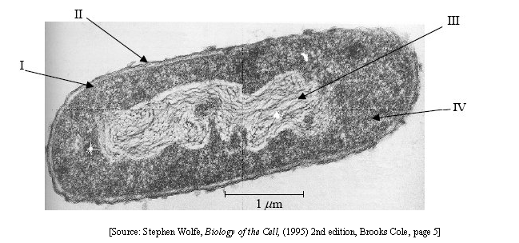

Identify the labelled structures:

I

II

III

IV

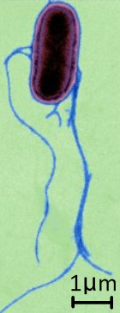
- This is an electron micrograph of the bacterium Salmonella typhi. Draw a diagram of the ultrastructure of the cell, clearly labelling as many structures as you can identify.

1.2.A2 Prokaryotes divide by binary fission.

- Outline the process of binary fission

- Is the process asexual or sexual? Compare the genetic content of the two daughter cells with the parent cell.

1.2.U2 Eukaryotes have a compartmentalized cell structure.

- Plant and animal cells are eukaryotic.
  - Define the term eukaryote.

  - Outline the benefits compartmentalisation provides to eukaryote cells compared when with prokaryotes.

1.2.A1 Structure and function of organelles within exocrine gland cells of the pancreas and within palisade mesophyll cells of the leaf.

- Complete the table to summary the organelles commonly found in eukaryotes.

Organelle | Function | Diagram (labelled where necessary) | How to identify it on an electron micrograph
Nucleus
Mitochondrion | Site of ATP production by aerobic respiration (if fat is used as a source of energy it is digested here) | 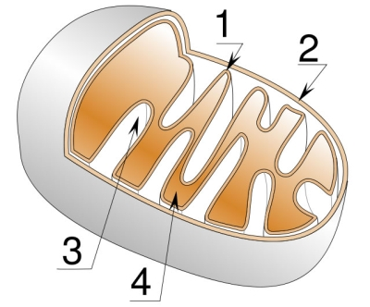 | Has a double membrane. A smooth outer membrane (2) and a folded inner membrane (1). The folds are referred to as cristae (3). The space in the middle is called the matrix (4). The shape varies.
Free
ribosomes
(80S)
Rough Endoplasmic Reticulum
(rER)
Image: http://www.sciencegeek.net/Biology/review/graphics/Unit2/mitochondrion.jpg

Organelle | Function | Diagram (labelled where necessary) | How to identify it on an electron micrograph
Golgi Apparatus
Vesicles
Lysosomes
Vacuoles
Flagellum
Cilia
Microtubules and
centrioles

Chloroplast

- Cell walls are not true organelles.
  - What is the function of the cell wall and where can it be found?

  - Explain why the cell wall is not considered an organelle.

  - In plant cells what is the cell wall mainly composed of?

1.2.S2 Drawing of the ultrastructure of eukaryotic cells based on electron micrographs.

- The ultrastructure of plant and animal cells is very different.
  - Distinguish between the structure of plant and animal cells

  - Draw and label the ultrastructure of a generalized eukaryote animal cell. Include all the relevant organelles from the two questions above.

  - Draw and label the ultrastructure of a generalized eukaryote Plant cell. Include all the relevant organelles from the two questions above.

- The image below shows a TEM micrograph of a liver cell.
  - Identify the labeled structures.
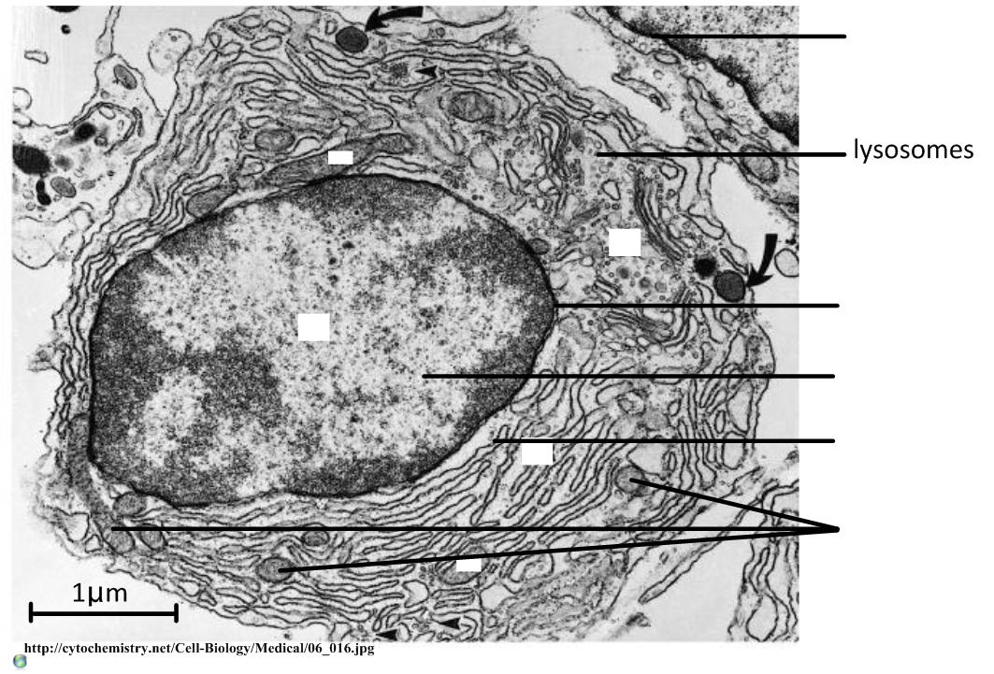

  - Calculate the magnification of the image.

  - Calculate the maximum diameter of the nucleus.

1.2.S3 Interpretation of electron micrographs to identify organelles and deduce the function of specialized cells.

- Deduce the function of each of the following images. For each deduction refer to the identified organelles and argue the evidence.
  - This image shows most of a single cell.
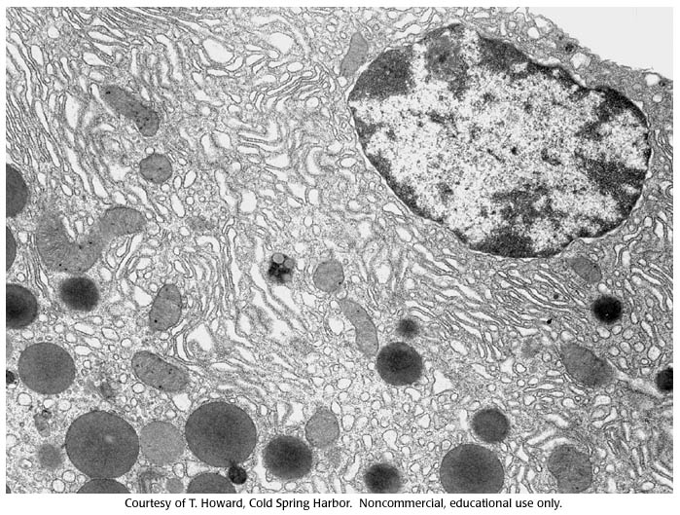

  - There are different tissues present. Deduce the function of the cells in the topmost layer.
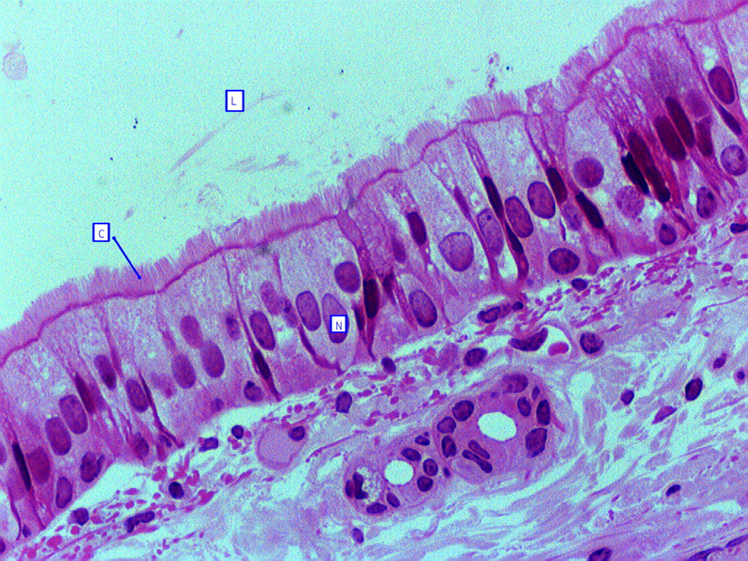
http://bcrc.bio.umass.edu/histology/files/images/Pseudostratified%20Columnar%20Ciliated%20Epithelium1.jpg

  - In this image you can see a complete cell in the middle of the image surrounded by similar cells.
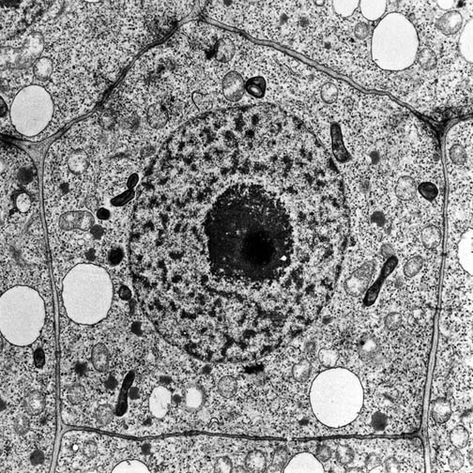
http://www.vcbio.science.ru.nl/images/tem-plant-cell.jpg

Citations:
Allott, Andrew. Biology: Course Companion. S.l.: Oxford UP, 2014. Print.

Taylor, Stephen. "Essential Biology 02.2 & 02.3 Prokaryotes and Eukaryotes.docx." Web. 19 Aug. 2014. <https://www.box.net/shared/y1kangxb9t >.

