Functions of life

MR H GREN

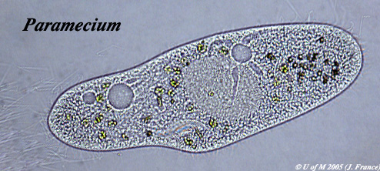

Source:
http://umanitoba.ca/Biology/BIOL1030/Lab1/biolab1_3.html#Ciliophora

Function | Description
M = Metabolism | Most metabolic pathways happen in the cytoplasm
R = Response | The wave action of the cilia moves the paramecium in response to changes in the environment, e.g. towards food.
H = Homeostasis | Contractile vacuole fill up with water and expel I through the plasma membrane to manage the water content
G = Growth | After consuming and assimilating biomass from food the paramecium will get larger until it divides.
R = Reproduction | The nucleus can divide to support cell division by mitosis, reproduction is often asexual
E = Excretion | The plasma membrane control the entry and exit of substances including expulsion of metabolic waste
N = Nutrition | Food vacuoles contain organisms the paramecium has consumed

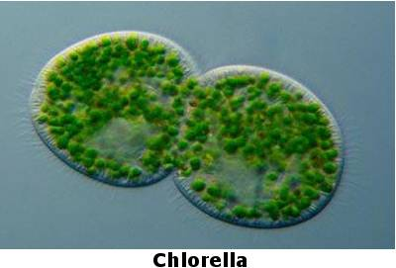
Source: http://www.algae.info/Algaecomplete.aspx

Function | Description
M | Most metabolic pathways happen in the cytoplasm
R | The wave action of the cilia moves the algae in response to changes in the environment, e.g. towards light.
H | Contractile vacuole fill up with water and expel I through the plasma membrane to manage the water content
G | After consuming and assimilating biomass from food the algae will get larger until it divides.
R | The nucleus can divide to support cell division, by mitosis (these cells are undergoing cytokinesis)
E | The plasma membrane control the entry and exit of substances including the diffusion out of waste oxygen.
N | Photosynthesis happens inside the chloroplasts to provide the algae with food

To what extent can fire be justified as living?

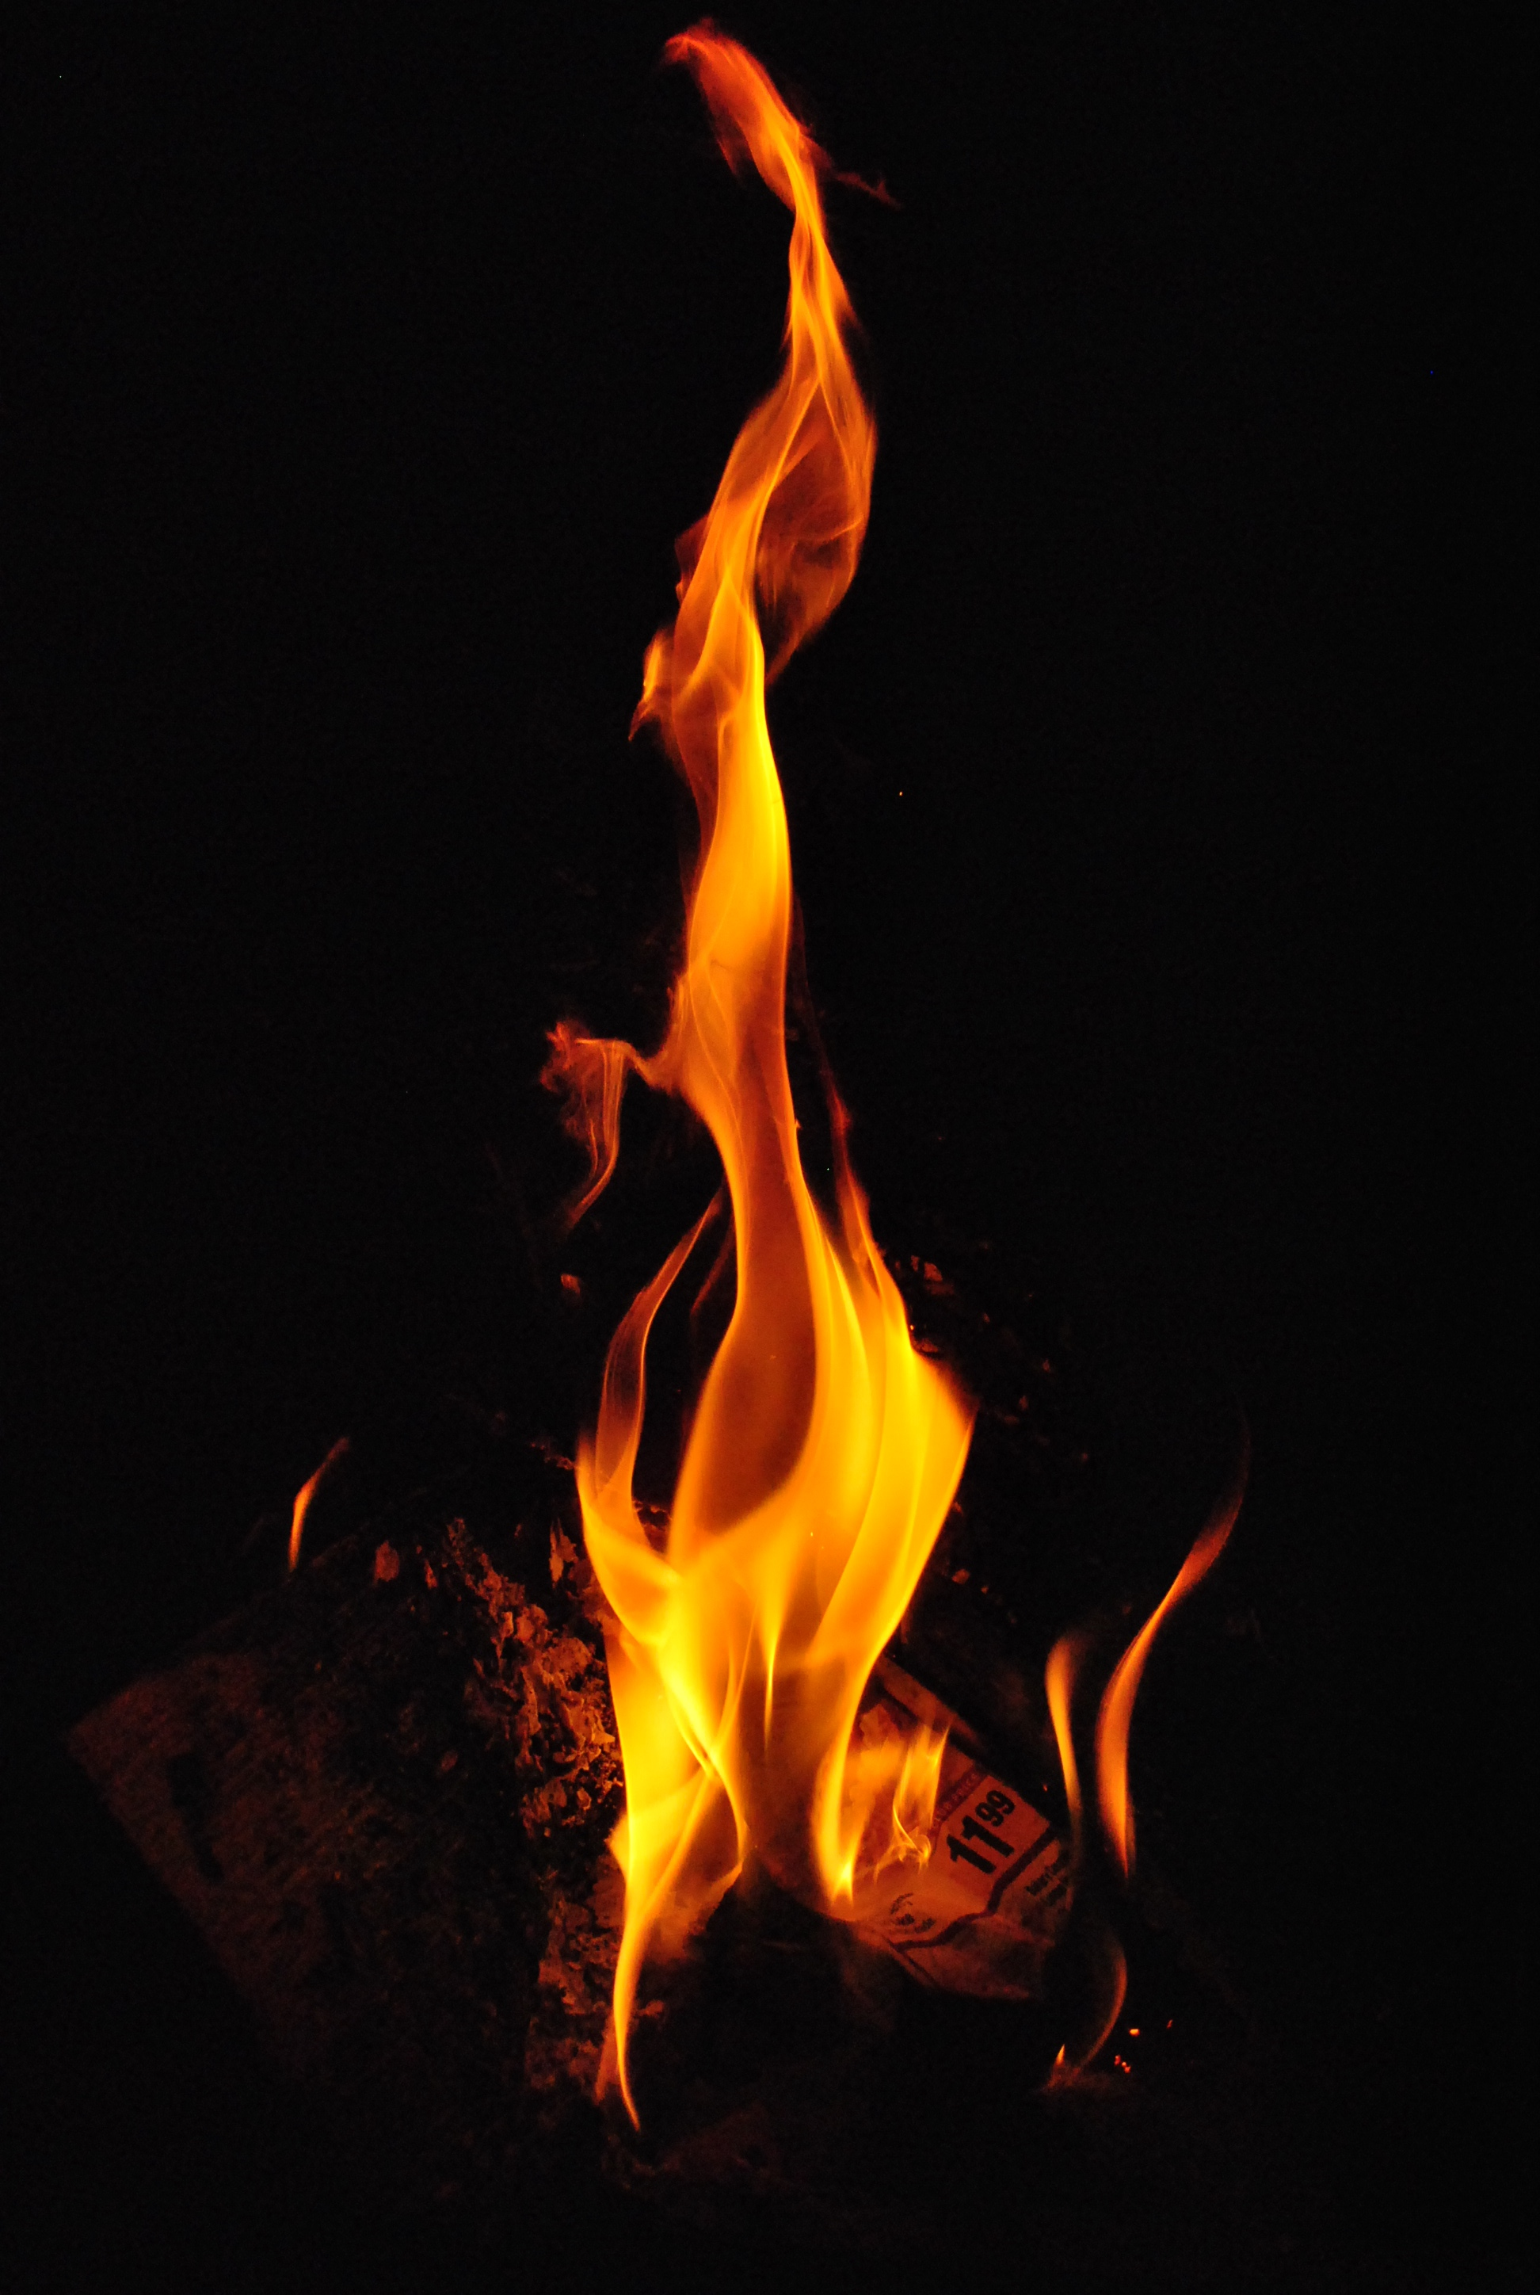

Function | Description
M
R
H
G
R
E
N

