Grade 10 Height vs Arm span…the graphing help file
So, multiple graphs need to be made. Here is a bit of help on how to do it.
FIRST
Make your data tables pretty. You need to have one for raw data (collected data) of males and one for females. Makes life easier. Next make sure you have a processed data table for mean (height and arm span), standard deviation (height and arm span), and correlation (comparing height and arm span). There should be processed for male and female.
Graph 1 – Scatter Graph
- Highlight the RAW data, both height and arm span of females.
- Insert chart Scatter
- Click the + symbol on the right of the graph and make sure you add trendlines and axis titles.
  - Be sure to make the ranges of the axis have the same decimal points as your data, you change this in the data setting to be “number” instead of “general” and set 1 decimal
- Click Chart filters and click the series (and the edit to the right of it). Name it female
- Click Chart filters and at the bottom click select data - add from legend side of the window
- Name the new data male and select the data (X is height, Y is arm span)
- Click the + symbol on the graph go to trendlines more options click male logarithmic
Should look something like this (but your data is different)
Male correlation = 0.99
Female correlation = 0.92
- Once copied into a word doc, insert textboxes for correlation values. Move them over graph

Graph 2 – Bar graph
For this you should be making multiple bar graphs.
- Select the data for male and female average arm span
- Use the chart filter menu to access this (by click select data in the bottom of the menu) 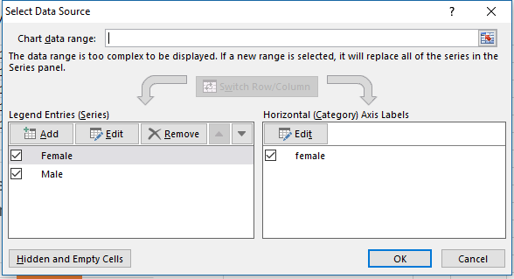
- You have to edit the legend entries on the right (name them and select ONLY the data you want, ie, male name and average male arm span)
- Add a new legend entry and edit it to be the opposite gender
- On each bar in the bar graph, click the + symbol error bars custom erro bars
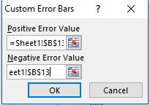
- Select the standard deviation (for the right gender and measurement, either arm span or height) more options custom error bars
- The positive and negative value are the same data in excel (the select looks like this)
- Repeat for both bars and you should get this.

Graphing Tips
- It is important to have your data set with the right decimal places first.
- Use the + symbol next to the graph to add axis and titles
- Use the to edit the data you have selected
- Make sure to have the uncertainties and decimal places match up.
- Legends are important for the bar graph because you need to see male and female. You can do it in the axis but is a bit annoying (so I skip it for a legend)
- You can delete axis titles and things easily but choose what helps the lab.

