IB Biology HL: Topic 6.4 Gas Exchange Notes
Ventilation maintains concentration gradients of oxygen and carbon dioxide between air in alveoli and blood flowing in adjacent capillaries.
Respiration is the transport of oxygen to cells where energy production takes place, and involves three key processes:
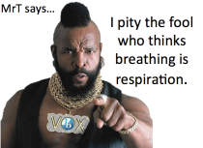
- Ventilation: The exchange of air between the lungs and the atmosphere; it is achieved by the physical act of breathing
- Gas exchange: The exchange of oxygen and carbon dioxide in the alveoli and the bloodstream; it occurs passively via diffusion
- Cell Respiration: The release of ATP from organic molecules; it is greatly enhanced by the presence of oxygen (aerobic respiration)

Why do humans need a ventilation system?
- Because gas exchange is a passive process, a ventilation system is needed to maintain a concentration gradient within the alveoli
- Oxygen is needed by cells to make ATP via aerobic respiration, while carbon dioxide is a waste product of this process and must be removed
- Oxygen must diffuse from the lungs into the blood, while carbon dioxide must diffuse from the blood into the lungs
- This requires a high concentration of oxygen - and a low concentration of carbon dioxide - in the lungs
- A ventilation system maintains this concentration gradient by continually cycling the air in the lungs with the atmosphere. If there were no ventilation, equilibrium would be reached and no gas would be exchanged.

Type I pneumocytes are extremely thin alveolar cells that are adapted to carry out gas exchange. Type II pneumocytes secrete a solution containing surfactant that creates a moist surface inside the alveoli to prevent the sides of the alveolus from adhering to each other by reducing surface tension.

Alveoli:
- Give lungs an increased SA:Vol ratio: High numbers of spherically-shaped alveoli optimize surface area for gas exchange (600 million alveoli = 80 m²)
- Have a rich capillary network: Alveoli are covered by a dense network of capillaries that help to maintain a concentration gradient
- Have a single layer of epithelial cells.

Most of the epithelial cells are Type I pneumocytes.
- Have a thin wall: Made of a single layer of flattened cells so that diffusion distance is small (less than 0.5 µm)
- This small diffusion distance is an adaption that increases the rate of gas exchange

About 5% of alveolar epithelium consists of Type II pneumocytes.
- Secrete fluid containing surfactant that coats inner surface of alveoli
- Surfactant has a similar structure as phospholipids in plasma membranes: hydrophilic heads face alveolar wall (where moisture containing water is) and hydrophobic tails face the air
- Keeps alveoli moist
- Allows oxygen gas to dissolve and diffuse into blood and carbon dioxide to evaporate and be exhaled
- Prevents alveoli from collapsing (through cohesion): surface tension of water would cause lung to collapse without surfactant
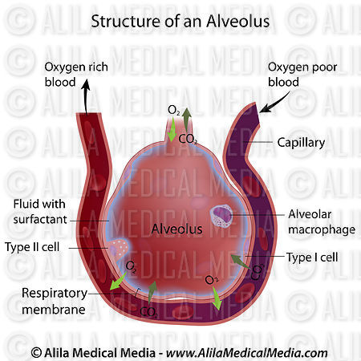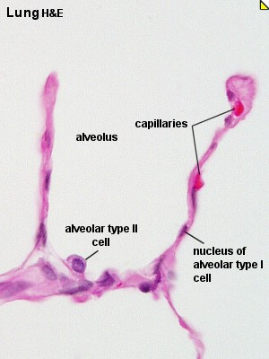
How many membranes must oxygen pass through in order to enter an erythrocyte?

Air is carried to the lungs in the trachea and bronchi and then to the alveoli in bronchioles.
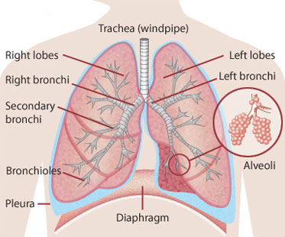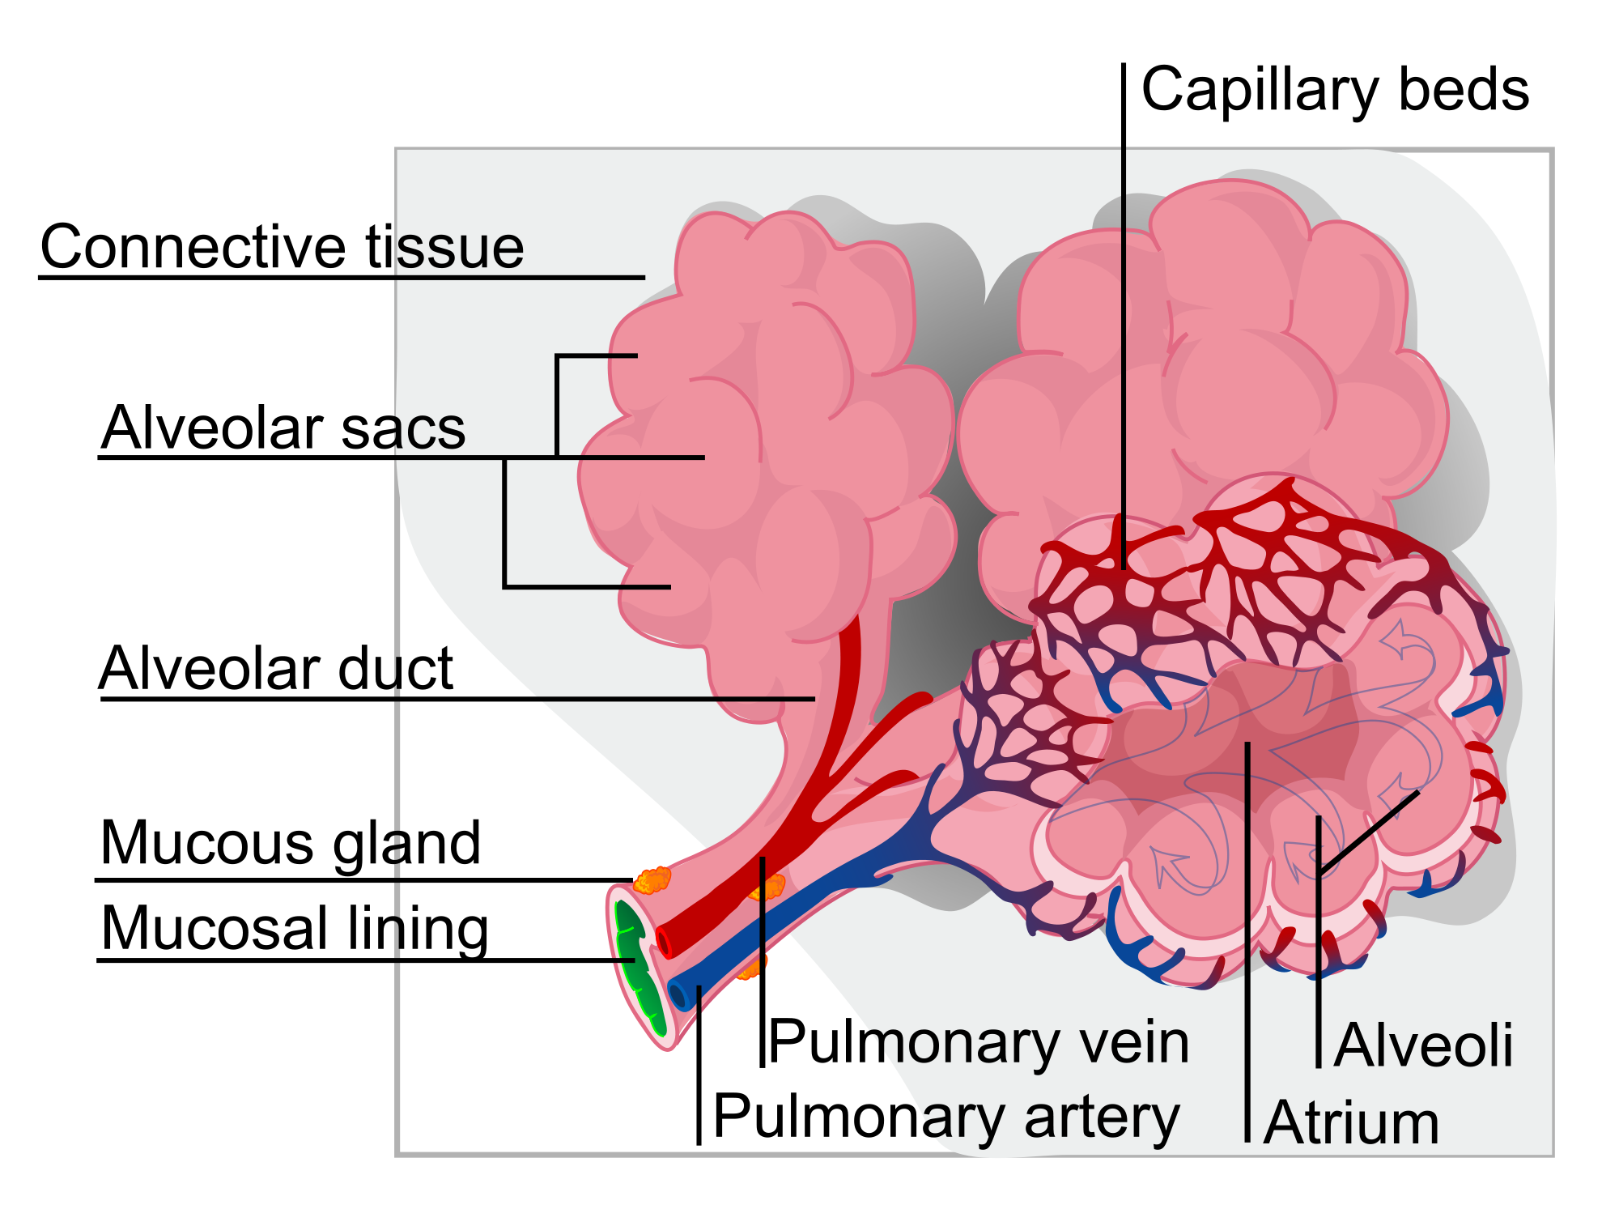

- Air enters through the nose or mouth and passes down the trachea.
- Trachea has rings of cartilage to keep it open as air pressure changes
- Trachea divides into two bronchi that lead into each lung – bronchi also have cartilage
- In the lung, bronchi divide into narrower airways called bronchioles (tree-like branching). Bronchioles have smooth muscle in walls that allow them to expand and contract.
- Alveoli are at the end of the narrowest bronchioles. Gas exchange occurs here.
Muscle contractions cause the pressure changes inside the thorax that force air in and out of the lungs to ventilate them. Different muscles are required for inspiration and expiration because muscles only do work when they contract.
- Breathing is the active movement of respiratory muscles that enable the passage of air to and from the lungs
- The mechanism of breathing is described as negative pressure breathing as it is driven by the creation of a negative pressure vacuum within the lungs, according to Boyle's Law (pressure is inversely proportional to volume)

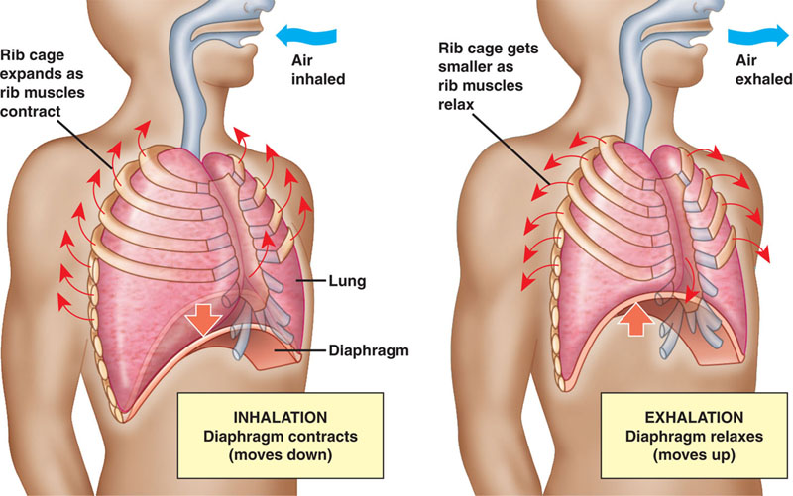
Inspiration
- Diaphragm muscles contract and flatten downwards, abdominal muscles relax
- External intercostal muscles contract, pulling ribs upwards and outwards
- This increases the volume of the thoracic cavity (and therefore lung volume)
- The pressure of air in the lungs is decreased below atmospheric pressure
- Air flows into the lungs to equalize the pressure

Expiration
- Diaphragm muscles relax and diaphragm curves upwards
- Abdominal muscles contract, pushing diaphragm upwards
- External intercostal muscles relax, allowing the ribs to fall
- Internal intercostal muscles contract, pulling ribs downwards
- This decreases the volume of the thoracic cavity (and therefore lung volume)
- The pressure of air in the lungs is increased above atmospheric pressure
- Air flows out of the lungs to equalize the pressure

External and internal intercostal muscles, and diaphragm and abdominal muscles as examples of antagonistic muscle action.

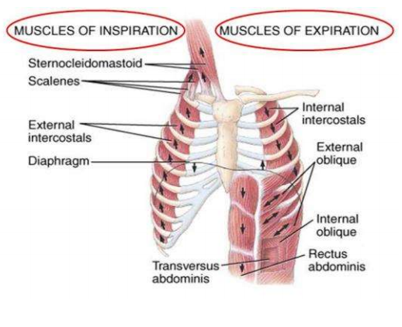
- When different muscles work together to perform opposite movements, they do so in an antagonistic fashion - when one muscle contracts the other relaxes
- When muscles contract and shorten (do work), they exert a pulling force that causes movement
- The antagonistic muscle relaxes and lengthens because of the pulling force of the other muscle (no work is done)
- For example, when one breathes in air, the external intercostal muscles contract, moving the ribcage up and out and the internal intercostal muscles relax (biceps and triceps work in similar fashion in our arms). The opposite occurs during expiration.
Causes and consequences of lung cancer.

Causes:

Smoking:
- Number one cause of lung cancer (87% of cases)
- Extremely high correlation with the number of cigarettes an individual smokes in a day and the incidence of lung cancer
- Cigarettes contain a large number of carcinogens, such as polycyclic aromatic hydrocarbons and nitrosamines
- Second-hand smoke can also be considered a cause of cancer in non-smokers (3% of cases)

Air Pollution:
- Exhaust fumes containing nitrogen oxides, fumes from diesel engines and smoke from burning carbon compounds such as coal are a minor cause of lung cancer.
- Depends on where in the world you live and the air quality.
Radon Gas:
- In some parts of the world, this radioactive gas can leak out of certain rocks such as granite, accumulating in poorly ventilated buildings.

Asbestos:
- Asbestos, silica and other dust particles can be in the air at construction sites, factories and mines.
- Workers who are not properly protected can develop lung cancer.

Consequences:
- Lung cancer is a very serious disease and the consequences can be severe, especially if the cancer is not recognized early on.
- Symptoms: difficulties with breathing, persistent coughing, coughing up blood, chest pain, loss of appetite, weight loss and general fatigue.
- If the tumor is large when it is discovered, metastasis might have occurred (cancer has spread to other parts of the body and formed secondary tumors). In these cases, mortality rates are very high (15% 5-year survival).
- If the tumor is found early on, parts of the affected lung with the tumor can be removed and chemotherapy/radiotherapy can be used to help kill the rest of the cancer cells.
- Survivors may have pain, breathing difficulties, fatigue and anxiety about the return of the cancer. Re-occurrence of the disease is quite common.

Causes and consequences of emphysema.

Causes:
- Emphysema is another respiratory disease that is often linked to smoking
- Emphysema is characterized by the loss of elasticity of the alveoli in the lungs, resulting in the destruction of lung tissue over time
- Phagocytes (white blood cells that engulf foreign bacteria) usually prevent lung infections and produce a hydrolytic enzyme called elastase
- An enzyme inhibitor usually prevents elastase from digesting lung tissue
- Smokers lungs generally contain a high number of these phagocytes/macrophages in their blood
- Since there is a higher level of phagocytes, more elastase is produced; however, not enough of the inhibitor that prevents elastase from digesting lung tissue
- This results in the destruction of elastic fibres of the alveolar walls by the enzyme elastase
- The alveoli can become over-inflated and fail to recoil properly
- Small holes can also develop in the walls of the alveoli
- The alveoli can merge forming huge air spaces and a lower surface area
Consequences:
- Damage to alveoli is irreversible.
- Low oxygen saturation in the blood and higher than normal carbon dioxide concentrations causes a patient to lack energy and have shortness of breath.
- Ventilation is labored and is more rapid than usual.
- In more advanced cases, patients have difficulty climbing stairs and completing similar tasks

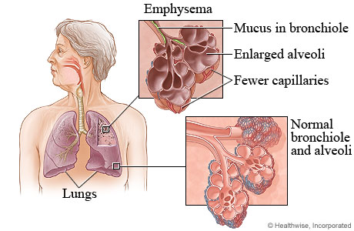
Draw and label a diagram of the structure of an alveolus and an adjacent capillary.

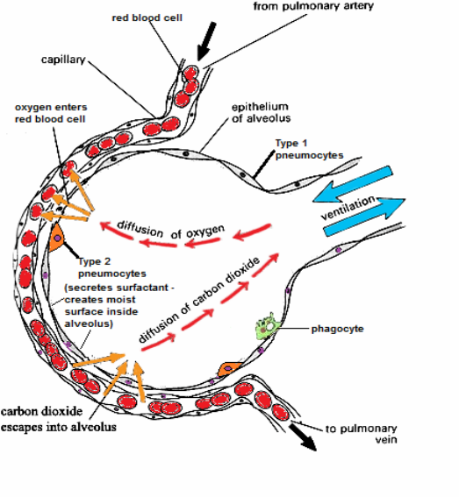
Some information from: http://ibworld.me/Physiology.html#6.4_Respiratory_System

