IB Biology HL: 11.3 The Kidney and Osmoregulation Notes
Excretion: the removal from the body of the waste products of metabolic activities (urine, sweat, expired air)
Egestion: the process of discharging undigested or waste material from a cell or organism (feces)
Drawing and labeling a diagram of the human kidney.
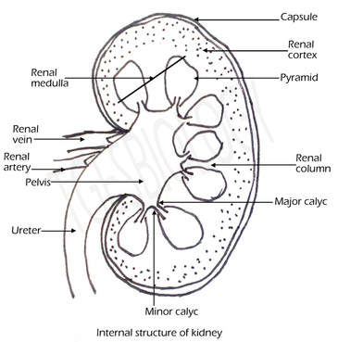
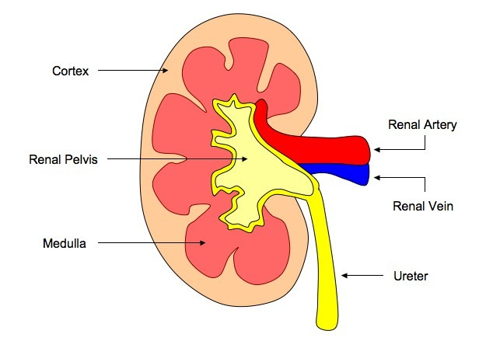

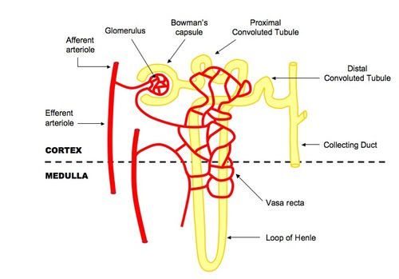
Annotation of diagrams of the nephron.
The nephron is the functional unit of the
kidney and includes:
Afferent arteriole: Brings blood to the
nephron to be filtered
Efferent arteriole: Removes blood from
nephron (minus filtered components)
Glomerulus: Capillary tuft where
filtration occurs
Bowman's Capsule: First part of
nephron where filtrate is collected
Proximal Convoluted Tubule:
Where selective reabsorption occurs
Loop of Henle: Important for establishing
a salt gradient in the medulla
Distal Convoluted Tubule: Final site of
selective reabsorption
Collecting Duct: Feeds into ureter and is
where osmoregulation occurs
Vasa Recta: Blood network that reabsorbs components from the filtrate

Animals are either osmoregulators or osmoconformers.
Osmolarity: refers to solute concentration of a solution

Osmoregulators: maintain a constant internal solute concentration regardless of the osmolarity of their environments
- all terrestrial animals, freshwater animals and some marine organisms (bony fish) are osmoregulators
- these marine organisms maintain solute concentration at about one-third of the concentration of seawater and about 10 times that of fresh water

Osmoconformers: animals whose internal solute concentration is the same as the concentration of solutes in the environment

The Malpighian tubule system in insects and the kidney carry out osmoregulation and removal of nitrogenous wastes.

- Hemolymph: fluid with characteristics of tissue fluid and blood; circulated throughout bodies of many invertebrates
- Uric acid: nitrogenous waste product of protein metabolism; toxic and must be excreted
- Malpighian tubules: branch off from intestinal tract
- Cells lining the tubules actively transport ions and uric acid from hemolymph into the lumen of the tubules
- This draws water by osmosis from the hemolymph through the walls of the tubules into the lumen
- Tubules empty contents into the gut
- In the hindgut, most of the water and salts are reabsorbed while the nitrogenous waste is excreted with feces

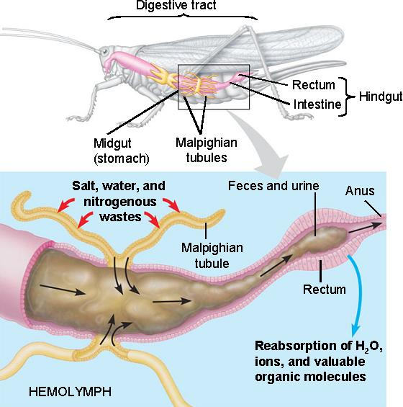

The composition of blood in the renal artery is different from that in the renal vein.

- Kidneys are responsible for osmoregulation and excretion – remove substances from blood that are not needed or are harmful
- Renal artery brings blood into kidney and renal vein brings blood out of kidney
- Substances in higher concentrations in the renal artery (compared to renal vein) include:
  - Toxins that are ingested and absorbed but not fully metabolized (ex. betain pigments in beets, drugs)
  - Excretory waste products including nitrogenous waste products (ex. urea)
  - Excess water and salt (not excretory waste products, part of osmoregulation) – concentrations of water and salt are more variable in the renal arteries and more constant in the renal veins
- Kidneys filter off about one-fifth of the volume of plasma from the blood flowing through them
- Filtrate contains all of the substances in the plasma except large protein molecules
- Kidneys then actively reabsorb specific substances the body needs and unwanted substances are eliminated in the urine
- Unwanted substances are present in the renal artery but not the vein
- Blood leaving the kidney through the renal vein is deoxygenated and has a higher partial pressure of CO₂ compared to the renal artery due to the metabolic activity of the kidney
- Some glucose is used for cellular respiration by the kidney, making the concentration in the renal vein slightly lower than in the renal artery

The ultrastructure of the glomerulus and Bowman’s capsule facilitate ultrafiltration.

- Ultrafiltration occurs when hydrostatic pressure forces plasma through a semi-permeable membrane, separating blood cells and large proteins from the remainder of the serum
- Ultrafiltration occurs between the glomerulus and the Bowman's capsule and requires two things to form the filtrate:
Hydrostatic Pressure
- The glomerulus increases blood pressure by forming narrow branches (which also increases surface area for filtration)
- This pressure is maintained by a narrow efferent arteriole (relative to the afferent arteriole), which restricts the outflow of blood, keeping pressure high
- The net pressure gradient in the glomerulus forces blood into the capsule space
Basement Membrane
- The basement membrane is a fine mesh that restricts the passage of blood cells and proteins - it is the sole filtration barrier
- Blood plasma can exit the glomerulus directly through pores as the capillaries are fenestrated
- The filtrate can enter the Bowman's capsule directly because the podocytes that surround the glomerulus contain filtration slits between their pedicels (foot processes)
- The basement membrane lies between the glomerulus and Bowman's capsule

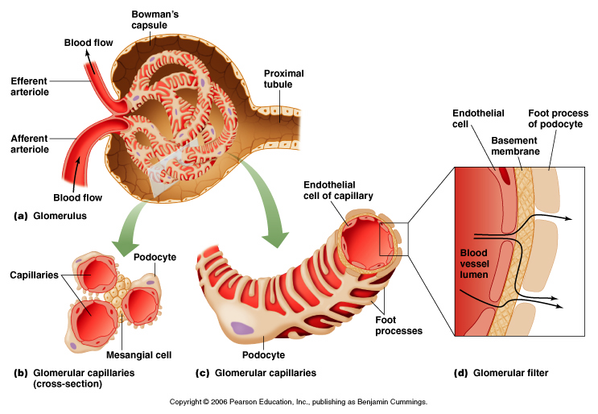
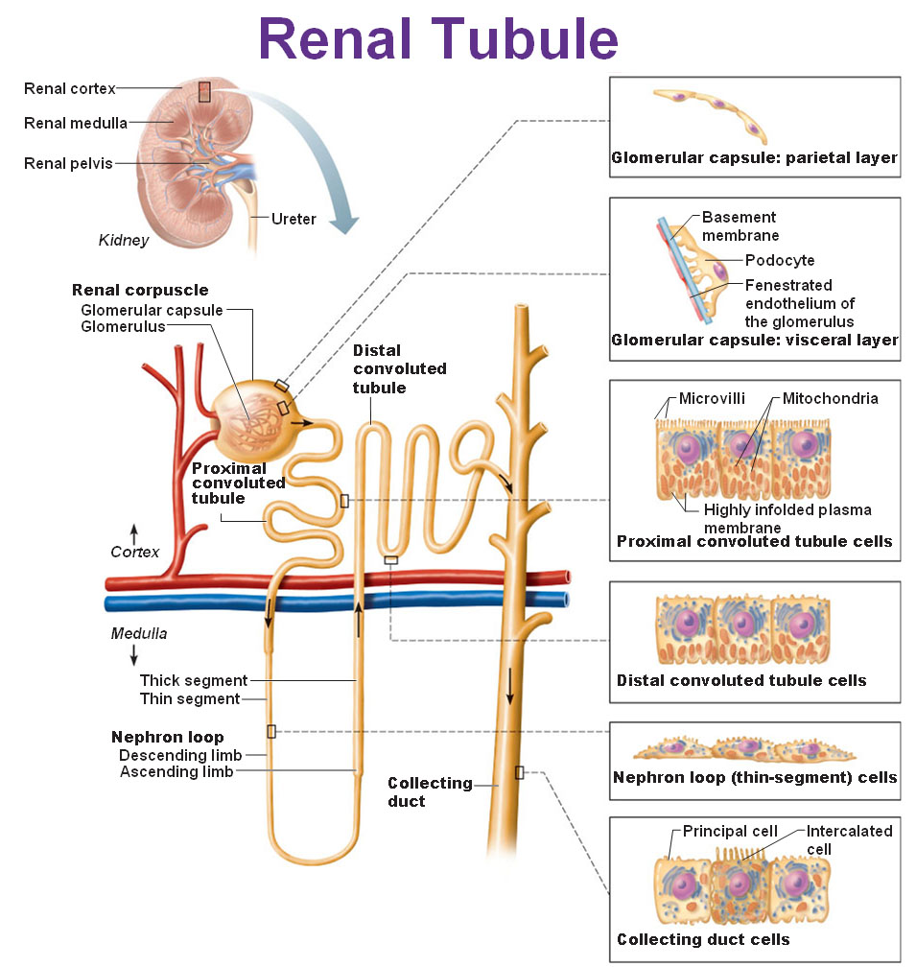
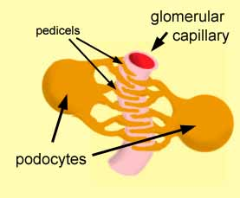
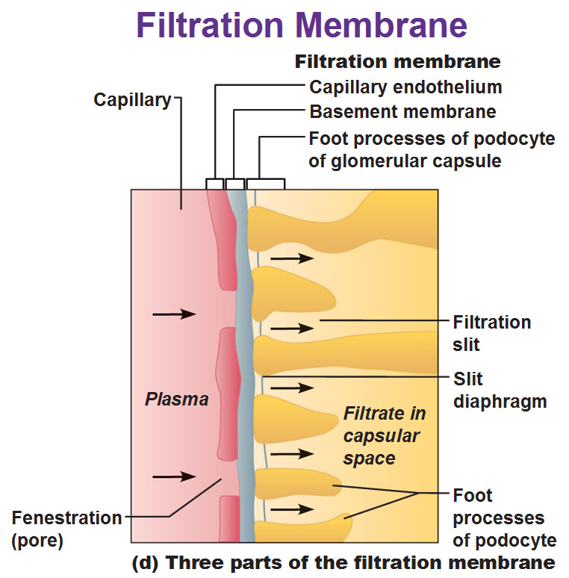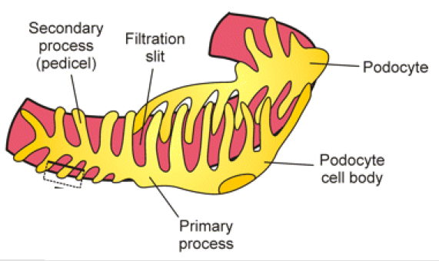
http://antranik.org/the-urinary-system-kidneys/
The proximal convoluted tubule selectively reabsorbs useful substances by active transport.
- The proximal convoluted tubule extends from the Bowman's capsule and is where most selective reabsorption in the nephron occurs
- All glucose, amino acids, vitamins and hormones are reabsorbed here, along with most (~80%) of the mineral ions and water
- The proximal convoluted tubule has a microvilli cell lining to increase the surface area for the absorption of materials from the filtrate
- There are also a large number of mitochondria in these cells, as reabsorption from the filtrate involves active transport
- Once materials have been activity reabsorbed into the tubule cells, they can passively diffuse into the bloodstream (along the concentration gradient)
- Mineral ions and vitamins are actively transported via protein pumps or carrier proteins
- Glucose is actively transported across the membrane in symport with sodium
- Water follows the movement of the ions passively (via osmosis)
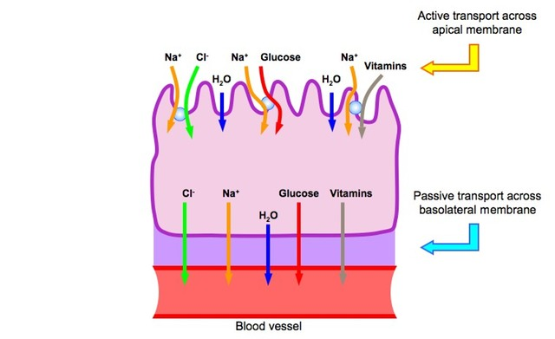
The loop of Henle maintains hypertonic conditions in the medulla.
Creating a Salt Gradient in the Medulla
- The function of the loop of Henle is to create a salt bath concentration in the fluid surrounding the tubule
- The descending limb of the loop of Henle is permeable to water, but impermeable to salts
- The ascending limb of the loop of Henle is permeable to salts, but impermeable to water
- This means that as the loop descends into the medulla, the interstitial fluid becomes more salty (and less salty as it ascends into the cortex)
- As the vasa recta blood network that surrounds the loop flows in the opposite direction (counter-current exchange), this further multiplies the effect (causes a steeper solute concentration gradient to form)
The length of the loop of Henle is positively correlated with the need for water conservation in animals.
- Some animals have relatively long loops of Henle - the longer the loop of Henle, the more water volume will be reclaimed
  - Animals adapted to dry habitats have longer loops of Henle
  - Loops of Henle are in the medulla - animals with longer loops of Henle have thicker medullas
ADH controls the reabsorption of water in the collecting duct.
Osmoregulation
- When the filtrate enters the distal convoluted tubule from the loop of Henle, it is hypotonic (more solutes than water passed out of the filtrate in the medulla)
- If solute concentration of blood is low, little water is reabsorbed as the filtrate passes through the distal convoluted tubule and collecting duct (urine volume is high and urine solute concentration is low; blood solute concentration increases)
- If solute concentration of blood is high:
  - Antidiuretic hormone (ADH or vasopressin - a hormone) is released from the posterior pituitary in response to dehydration (detected by hypothalamus)
  - ADH increases the permeability of the collecting duct to water, allowing more water to be reabsorbed by osmosis (via the production of aquaporins) and decreasing blood solute concentration
  - This means less water remains in the filtrate and the urine becomes more concentrated
  - Helped by high solute concentration of medulla - as collecting duct travels through medulla, water leaves filtrate and is reabsorbed
- When the individual is suitably rehydrated, ADH levels will decrease and less water will be reabsorbed from the collecting ducts
Osmoregulation in the Medulla
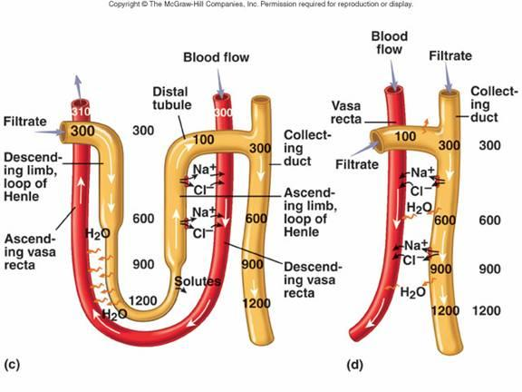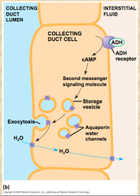
http://courses.washington.edu/conj/bess/water/water.htm

Summary: Difference in the concentration of proteins, glucose and urea between blood plasma, glomerular filtrate and urine:
Proteins:
- Proteins will be present in blood plasma, but not present in glomerular filtrate or urine
- This is because proteins cannot pass across the basement membrane during ultrafiltration and thus cannot form part of the filtrate

Glucose:
- Glucose will be present in blood plasma and glomerular filtrate, but not present in urine (normally)
- This is because the glucose is selectively reabsorbed in the proximal convoluted tubule
- It is reabsorbed from the filtrate into the blood by active transport (symport with Na⁺ ions)

Urea:
- Urea will be present in blood plasma, glomerular filtrate and urine
- Only about 50% of urea is reabsorbed (some urea is reabsorbed to help regulate the medullary osmolarity gradient)
- Because water is reabsorbed from the filtrate (by osmosis, due to the hypertonicity of the medulla), urea becomes more concentrated in urine
- The concentration of urea in the urine will depend on the amount of water in the urine
The type of nitrogenous waste in animals is correlated with evolutionary history and habitat.
- Breakdown of amino acids and nucleic acids forms ammonia (nitrogenous waste)
- Ammonia is highly basic (can alter pH), toxic and highly reactive
- Organisms that live in marine or freshwater habitats release ammonia directly (becomes diluted by water in environment)
- Terrestrial organisms expend energy to convert ammonia to the less toxic urea or uric acid, depending on habitat and evolutionary history
  - Ex: marine mammals release urea (not ammonia) because of evolutionary history
  - Ex: amphibians release ammonia while in larval stage and urea after metamorphosis
- Converting ammonia to uric acid requires more energy than converting to urea
- Advantage: uric acid is not water soluble and does not need water to be released
  - Ex: birds and insects release uric acid - birds do not need to carry extra water to release waste (less energy needed for flight)
  - Ex: organisms that develop in eggs release uric acid - crystallizes rather than building up to toxic levels in the egg
Consequences of dehydration and overhydration.
- Dehydration: more water leaves body than comes in (exercise, insufficient water intake, diarrhea) - disrupts metabolic processes which rely on water
- Signs:
  - darkened urine due to increased solute concentration
  - lethargy/tiredness due to build up of metabolic wastes that need water be removed
  - low blood pressure due to low blood volume
  - increased heart rate due to low blood pressure
  - difficulty regulating body temperature due to reduced sweat production

- Overhydration: over consumption of water - leads to dilution of blood solutes
  - Ex: after exercise, large amount of water consumed without replacing electrolytes
  - Makes body fluids hypotonic and could lead to swelling of cells
  - Signs: headache and nerve function disruption
Treatment for kidney failure by hemodialysis or kidney transplant.
- Kidney failure: most commonly due to diabetes or chronic high blood pressure (due to diabetes)
- Hemodialysis: treatment required when kidneys are no longer able to filter waste products from blood properly
  - Drawbacks: inconvenient and time consuming, risk of infection and other complications
- Alternative: kidney transplant
  - Drawback: organ rejection
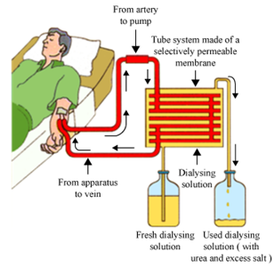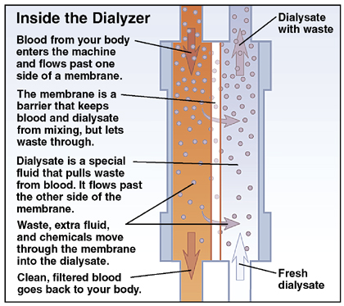
Urinalysis
- Blood cells, glucose, proteins and drugs are detected in urinary tests
- Urine is a product of osmoregulation, excretion and metabolism
- Processes can be disrupted by illness or drug abuse
- Urinalysis examines urine for deviation from normal composition

Test kit: color changes on strip dipped in urine indicate pH, levels of glucose or protein (high glucose and protein indicate diabetes)

- High protein levels indicate kidney damage since protein should not get through ultrafiltration in a healthy kidney
- The urine of non-diabetic patients should contain no glucose as it is selectively reabsorbed from the filtrate in the proximal convoluted tubule
- Diabetics have higher levels of blood glucose due to either a lack of insulin secretion (type I) or insensitivity to insulin secretions (type II)
- Because of this, not all of the glucose in diabetics is reabsorbed into the blood (protein pumps in tubule wall become saturated)
- This results in the presence of glucose in the urine of untreated diabetics

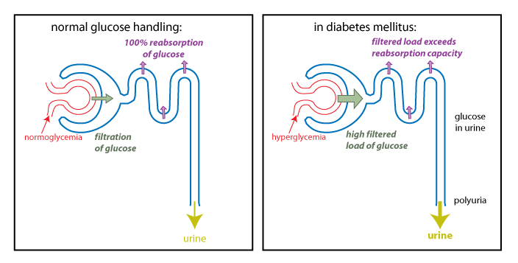

Drug test kits use test strips based on monoclonal antibody technology (similar to pregnancy test kits)

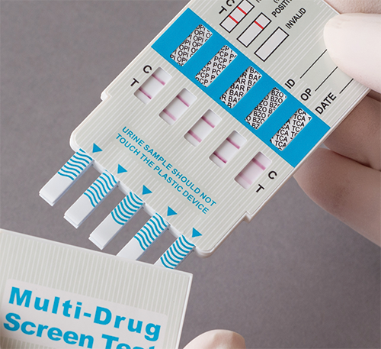

Microscopic examination determines if cells are present in urine that should not be there:
- white blood cells indicate infection
- red blood cells indicate kidney stones or tumors

